1. **Foundations**: Organize journal.html by adding ids, classes, spans, and divs. Then, add borders around these sections by editing your journal.css. The borders are all 5px thick and solid. The colors are the intuitive HTML color names. For ex. red is color: red    Hint: To reduce the needed id and class as attribute, consider using CSS context selectors.  There is may be no need to change any content of HTML except adding containers and style.  After you are done, your output should look similar to this:

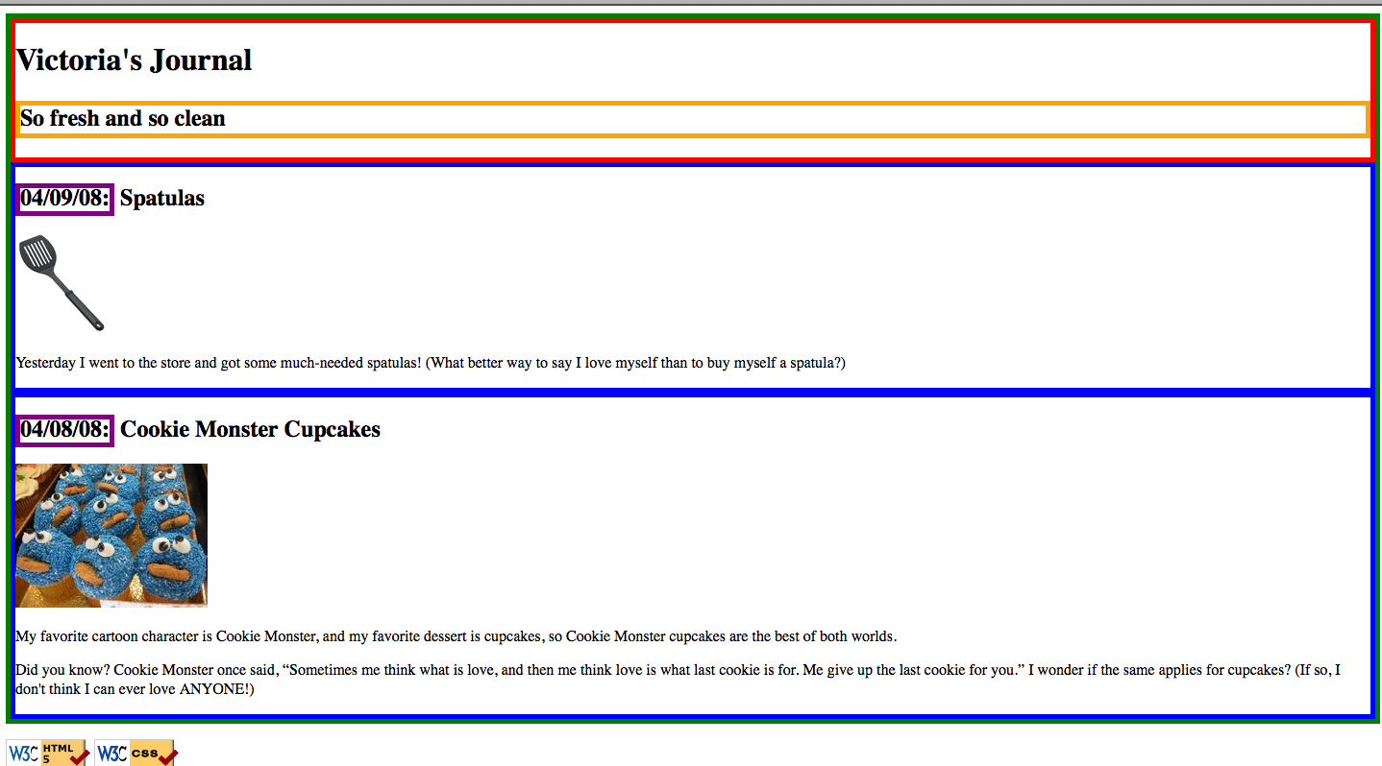

1. **Style**: Add padding, margins, backgrounds to the page. Change only your journal.css.  The box with the green border should have a background color of white.  The box with the blue borders should have a background color of #E8FBFB. It should have a padding of 5px (on all sides) and margin of 10px only on the top of the box.  The overall page content should be centered on the page, should have left and right margin of 10%. Add a background image of your own choice.

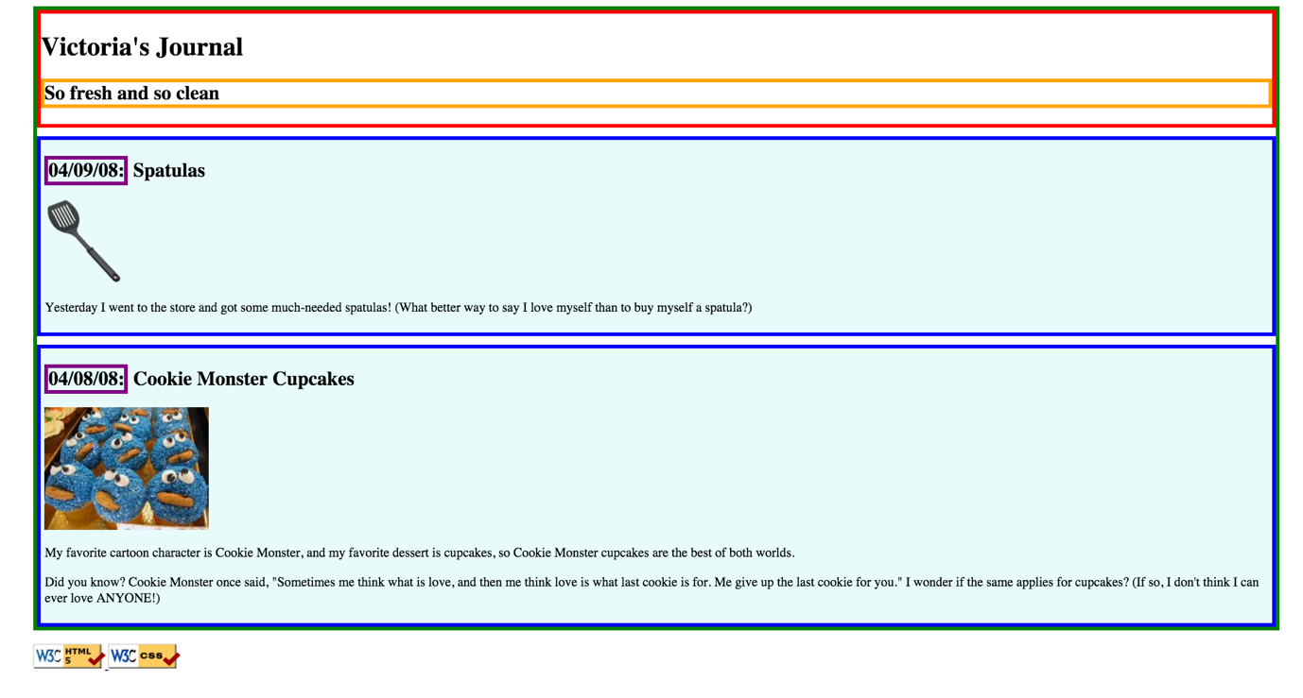

1. **Look & Feel**: Now, we will practice float, clear, and alignment. You may have to edit journal.html code as well as journal.css    The heading text in the red box should appear on the right side of the section page.  The text of each journal entry should be widened so that each line fills the entire width of the section. (justified).  The journal entry images should hover on the right side next to the surrounding text. The images should stay within the boundary of the blue box.  You can refer to this chapter for how to make float element fit:  <http://www.webstepbook.com/samples/ch04-layout.pdf>

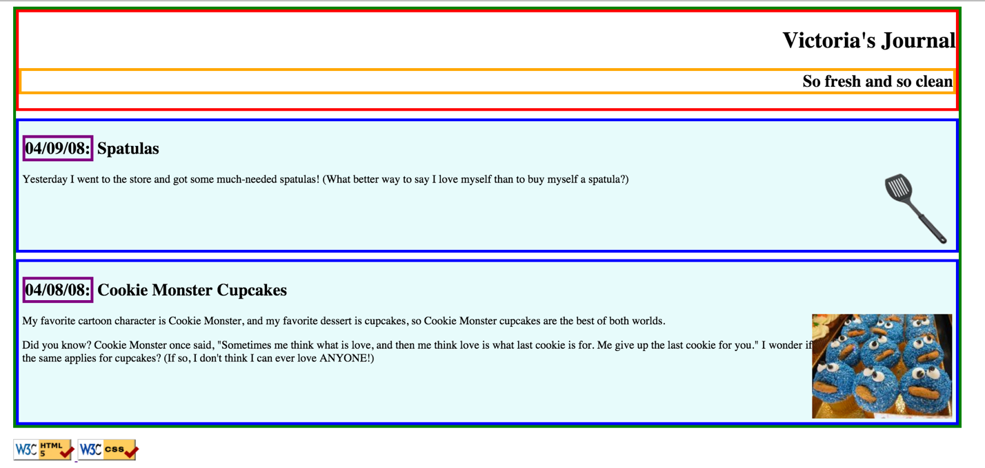

1. **Final touches**: Change the box with green border to have a solid, white, 10px-thick border.  Change the boxes with the blue border to have a solid, 4px-thick border, in color #C239E9, with a 15px rounded border radius.  Chang the box with the purple border to have only a bottom border: blue, dashed, and 2px thick.   Change the box with the red border to have a background color of #A8F0F0, and get rid of its border.   Change the font size of the “So fresh and so clean” area to 14pt, and get rid of its border.

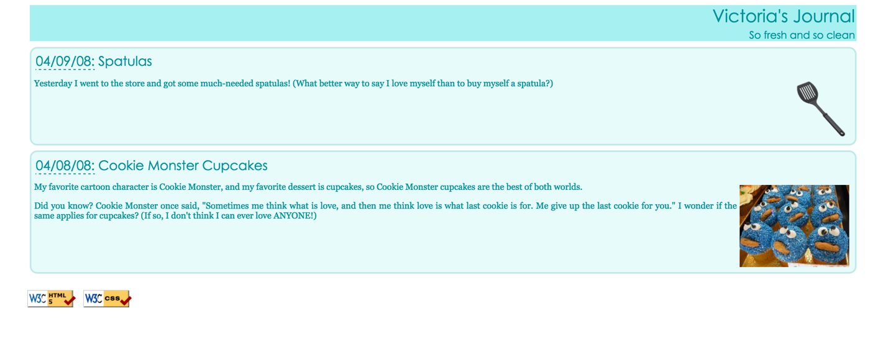

1. **User form:** Add form to your journal (journal.html) for a user to add journal entries to the journal page. The journal form ought to have a title text field, journal entry text box, and a text field for an image URL address. Use the appropriate layout-related tags/attributes and CSS to append the new entry to the list and have the same look and feel as the rest of the entries. The colors, borders, etc. of the list are not important; the focus is on the layout. Write your JavaScript code into journal.js file. This file will contain a function that takes the data from the form and appends it to the list of journal entries. The layout with with the form must still be a “liquid” layout -- that is, all parts of it should adjust in size accordingly when the browser size changes.  Hint: When multiple elements float in the same direction, they arrange themselves into columns.